CONGREGATION
FOR THE DOCTRINE OF THE FAITH
THE MESSAGE OF FATIMA

INTRODUCTION
As the second millennium gives way to the third, Pope John Paul II has decided to publish the text of the third part of the “secret of Fatima”.
The twentieth century was one of the most crucial in human history, with its tragic and cruel events culminating in the assassination attempt on the “sweet Christ on earth”. Now a veil is drawn back on a series of events which make history and interpret it in depth, in a spiritual perspective alien to present-day attitudes, often tainted with rationalism.
Throughout history there have been supernatural apparitions and signs which go to the heart of human events and which, to the surprise of believers and non-believers alike, play their part in the unfolding of history. These manifestations can never contradict the content of faith, and must therefore have their focus in the core of Christ's proclamation: the Father's love which leads men and women to conversion and bestows the grace required to abandon oneself to him with filial devotion. This too is the message of Fatima which, with its urgent call to conversion and penance, draws us to the heart of the Gospel.
Fatima is undoubtedly the most prophetic of modern apparitions. The first and second parts of the “secret”—which are here published in sequence so as to complete the documentation—refer especially to the frightening vision of hell, devotion to the Immaculate Heart of Mary, the Second World War, and finally the prediction of the immense damage that Russia would do to humanity by abandoning the Christian faith and embracing Communist totalitarianism.
In 1917 no one could have imagined all this: the three pastorinhos of Fatima see, listen and remember, and Lucia, the surviving witness, commits it all to paper when ordered to do so by the Bishop of Leiria and with Our Lady's permission.
For the account of the first two parts of the “secret”, which have already been published and are therefore known, we have chosen the text written by Sister Lucia in the Third Memoir of 31 August 1941; some annotations were added in the Fourth Memoir of 8 December 1941.
The third part of the “secret” was written “by order of His Excellency the Bishop of Leiria and the Most Holy Mother ...” on 3 January 1944.
There is only one manuscript, which is here reproduced photostatically. The sealed envelope was initially in the custody of the Bishop of Leiria. To ensure better protection for the “secret” the envelope was placed in the Secret Archives of the Holy Office on 4 April 1957. The Bishop of Leiria informed Sister Lucia of this.
According to the records of the Archives, the Commissary of the Holy Office, Father Pierre Paul Philippe, OP, with the agreement of Cardinal Alfredo Ottaviani, brought the envelopecontaining the third part of the “secret of Fatima” to Pope John XXIII on 17 August 1959. “After some hesitation”, His Holiness said: “We shall wait. I shall pray. I shall let you know what I decide”.⁽¹⁾
In fact Pope John XXIII decided to return the sealed envelope to the Holy Office and not to reveal the third part of the “secret”.
Paul VI read the contents with the Substitute, Archbishop Angelo Dell'Acqua, on 27 March 1965, and returned the envelope to the Archives of the Holy Office, deciding not to publish the text.
John Paul II, for his part, asked for the envelope containing the third part of the “secret” following the assassination attempt on 13 May 1981. On 18 July 1981 Cardinal Franjo Šeper, Prefect of the Congregation, gave two envelopes to Archbishop Eduardo Martínez Somalo, Substitute of the Secretariat of State: one white envelope, containing Sister Lucia's original text in Portuguese; the other orange, with the Italian translation of the “secret”. On the following 11 August, Archbishop Martínez returned the two envelopes to the Archives of the Holy Office.⁽²⁾
As is well known, Pope John Paul II immediately thought of consecrating the world to the Immaculate Heart of Mary and he himself composed a prayer for what he called an “Act of Entrustment”, which was to be celebrated in the Basilica of Saint Mary Major on 7 June 1981, the Solemnity of Pentecost, the day chosen to commemorate the 1600th anniversary of the First Council of Constantinople and the 1550th anniversary of the Council of Ephesus. Since the Pope was unable to be present, his recorded Address was broadcast. The following is the part which refers specifically to the Act of Entrustment:
“Mother of all individuals and peoples, you know all their sufferings and hopes. In your motherly heart you feel all the struggles between good and evil, between light and darkness, that convulse the world: accept the plea which we make in the Holy Spirit directly to your heart, and embrace with the love of the Mother and Handmaid of the Lord those who most await this embrace, and also those whose act of entrustment you too await in a particular way. Take under your motherly protection the whole human family, which with affectionate love we entrust to you, O Mother. May there dawn for everyone the time of peace and freedom, the time of truth, of justice and of hope”.(3)
In order to respond more fully to the requests of “Our Lady”, the Holy Father desired to make more explicit during the Holy Year of the Redemption the Act of Entrustment of 7 May 1981, which had been repeated in Fatima on 13 May 1982. On 25 March 1984 in Saint Peter's Square, while recalling the fiat uttered by Mary at the Annunciation, the Holy Father, in spiritual union with the Bishops of the world, who had been “convoked” beforehand, entrusted all men and women and all peoples to the Immaculate Heart of Mary, in terms which recalled the heartfelt words spoken in 1981:
“O Mother of all men and women, and of all peoples, you who know all their sufferings and their hopes, you who have a mother's awareness of all the struggles between good and evil, between light and darkness, which afflict the modern world, accept the cry which we, moved by the Holy Spirit, address directly to your Heart. Embrace with the love of the Mother and Handmaid of the Lord, this human world of ours, which we entrust and consecrate to you, for we are full of concern for the earthly and eternal destiny of individuals and peoples.
In a special way we entrust and consecrate to you those individuals and nations which particularly need to be thus entrusted and consecrated.
‘We have recourse to your protection, holy Mother of God!' Despise not our petitions in our necessities”.
The Pope then continued more forcefully and with more specific references, as though commenting on the Message of Fatima in its sorrowful fulfilment:
“Behold, as we stand before you, Mother of Christ, before your Immaculate Heart, we desire, together with the whole Church, to unite ourselves with the consecration which, for love of us, your Son made of himself to the Father: ‘For their sake', he said, ‘I consecrate myself that they also may be consecrated in the truth' (Jn 17:19). We wish to unite ourselves with our Redeemer in this his consecration for the world and for the human race, which, in his divine Heart, has the power to obtain pardon and to secure reparation.
The power of this consecrationlasts for all time and embraces all individuals, peoples and nations. It overcomes every evil that the spirit of darkness is able to awaken, and has in fact awakened in our times, in the heart of man and in his history.
How deeply we feel the need for the consecration of humanity and the world—our modern world—in union with Christ himself! For the redeeming work of Christ must be shared in by the world through the Church.
The present Year of the Redemption shows this: the special Jubilee of the whole Church.
Above all creatures, may you be blessed, you, the Handmaid of the Lord, who in the fullest way obeyed the divine call!
Hail to you, who are wholly united to the redeeming consecration of your Son!
Mother of the Church! Enlighten the People of God along the paths of faith, hope, and love! Enlighten especially the peoples whose consecration and entrustment by us you are awaiting. Help us to live in the truth of the consecration of Christ for the entire human family of the modern world.
In entrusting to you, O Mother, the world, all individuals and peoples, we also entrust to you this very consecration of the world, placing it in your motherly Heart.
Immaculate Heart! Help us to conquer the menace of evil, which so easily takes root in the hearts of the people of today, and whose immeasurable effects already weigh down upon our modern world and seem to block the paths towards the future!
From famine and war, deliver us.
From nuclear war, from incalculable self-destruction, from every kind of war, deliver us.
From sins against the life of man from its very beginning, deliver us.
From hatred and from the demeaning of the dignity of the children of God, deliver us.
From every kind of injustice in the life of society, both national and international, deliver us.
From readiness to trample on the commandments of God, deliver us.
From attempts to stifle in human hearts the very truth of God, deliver us.
From the loss of awareness of good and evil, deliver us.
From sins against the Holy Spirit, deliver us, deliver us.
Accept, O Mother of Christ, this cry laden with the sufferings of all individual human beings, laden with the sufferings of whole societies.
Help us with the power of the Holy Spirit to conquer all sin: individual sin and the ‘sin of the world', sin in all its manifestations.
Let there be revealed, once more, in the history of the world the infinite saving power of the Redemption: the power of merciful Love! May it put a stop to evil! May it transform consciences! May your Immaculate Heart reveal for all the light of Hope!”.(4)
Sister Lucia personally confirmed that this solemn and universal act of consecration corresponded to what Our Lady wished (“Sim, està feita, tal como Nossa Senhora a pediu, desde o dia 25 de Março de 1984”: “Yes it has been done just as Our Lady asked, on 25 March 1984”: Letter of 8 November 1989). Hence any further discussion or request is without basis.
In the documentation presented here four other texts have been added to the manuscripts of Sister Lucia: 1) the Holy Father's letter of 19 April 2000 to Sister Lucia; 2) an account of the conversation of 27 April 2000 with Sister Lucia; 3) the statement which the Holy Father appointed Cardinal Angelo Sodano, Secretary of State, to read on 13 May 2000; 4) the theological commentary by Cardinal Joseph Ratzinger, Prefect of the Congregation for the Doctrine of the Faith.
Sister Lucia had already given an indication for interpreting the third part of the “secret” in a letter to the Holy Father, dated 12 May 1982:
“The third part of the secret refers to Our Lady's words: ‘If not [Russia] will spread her errors throughout the world, causing wars and persecutions of the Church. The good will be martyred; the Holy Father will have much to suffer; various nations will be annihilated' (13-VII-1917).
The third part of the secret is a symbolic revelation, referring to this part of the Message, conditioned by whether we accept or not what the Message itself asks of us: ‘If my requests are heeded, Russia will be converted, and there will be peace; if not, she will spread her errors throughout the world, etc.'.
Since we did not heed this appeal of the Message, we see that it has been fulfilled, Russia has invaded the world with her errors. And if we have not yet seen the complete fulfilment of the final part of this prophecy, we are going towards it little by little with great strides. If we do not reject the path of sin, hatred, revenge, injustice, violations of the rights of the human person, immorality and violence, etc.
And let us not say that it is God who is punishing us in this way; on the contrary it is people themselves who are preparing their own punishment. In his kindness God warns us and calls us to the right path, while respecting the freedom he has given us; hence people are responsible”.(5)
The decision of His Holiness Pope John Paul II to make public the third part of the “secret” of Fatima brings to an end a period of history marked by tragic human lust for power and evil, yet pervaded by the merciful love of God and the watchful care of the Mother of Jesus and of the Church.
The action of God, the Lord of history, and the co-responsibility of man in the drama of his creative freedom, are the two pillars upon which human history is built.
Our Lady, who appeared at Fatima, recalls these forgotten values. She reminds us that man's future is in God, and that we are active and responsible partners in creating that future.
Tarcisio Bertone, SDB
Archbishop Emeritus of Vercelli
Secretary of the Congregation for the Doctrine of the Faith
THE “SECRET” OF FATIMA
FIRST AND SECOND PART OF THE “SECRET”
ACCORDING TO THE VERSION PRESENTED BY SISTER LUCIA
IN THE “THIRD MEMOIR” OF 31 AUGUST 1941 FOR THE BISHOP OF LEIRIA-FATIMA
(original text)
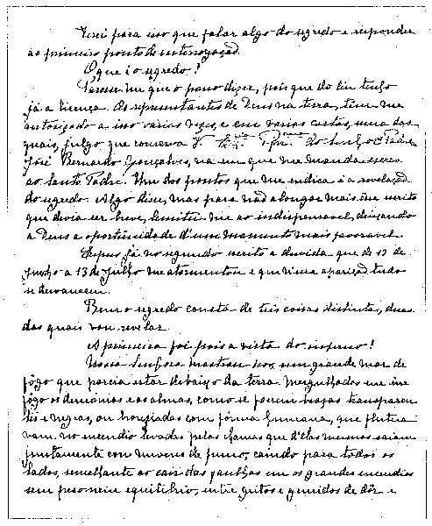
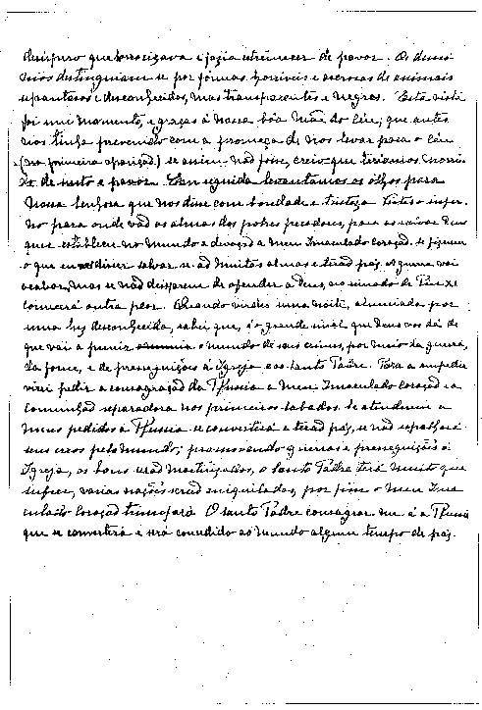
(translation) ⁽⁶⁾
... This will entail my speaking about the secret, and thus answering the first question.
What is the secret? It seems to me that I can reveal it, since I already have permission from Heaven to do so. God's representatives on earth have authorized me to do this several times and in various letters, one of which, I believe, is in your keeping. This letter is from Father José Bernardo Gonçalves, and in it he advises me to write to the Holy Father, suggesting, among other things, that I should reveal the secret. I did say something about it. But in order not to make my letter too long, since I was told to keep it short, I confined myself to the essentials, leaving it to God to provide another more favourable opportunity.
In my second account I have already described in detail the doubt which tormented me from 13 June until 13 July, and how it disappeared completely during the Apparition on that day.
Well, the secret is made up of three distinct parts, two of which I am now going to reveal.
The first part is the vision of hell.
Our Lady showed us a great sea of fire which seemed to be under the earth. Plunged in this fire were demons and souls in human form, like transparent burning embers, all blackened or burnished bronze, floating about in the conflagration, now raised into the air by the flames that issued from within themselves together with great clouds of smoke, now falling back on every side like sparks in a huge fire, without weight or equilibrium, and amid shrieks and groans of pain and despair, which horrified us and made us tremble with fear. The demons could be distinguished by their terrifying and repulsive likeness to frightful and unknown animals, all black and transparent. This vision lasted but an instant. How can we ever be grateful enough to our kind heavenly Mother, who had already prepared us by promising, in the first Apparition, to take us to heaven. Otherwise, I think we would have died of fear and terror.
We then looked up at Our Lady, who said to us so kindly and so sadly:
“You have seen hell where the souls of poor sinners go. To save them, God wishes to establish in the world devotion to my Immaculate Heart. If what I say to you is done, many souls will be saved and there will be peace. The war is going to end: but if people do not cease offending God, a worse one will break out during the Pontificate of Pius XI. When you see a night illumined by an unknown light, know that this is the great sign given you by God that he is about to punish the world for its crimes, by means of war, famine, and persecutions of the Church and of the Holy Father. To prevent this, I shall come to ask for the consecration of Russia to my Immaculate Heart, and the Communion of reparation on the First Saturdays. If my requests are heeded, Russia will be converted, and there will be peace; if not, she will spread her errors throughout the world, causing wars and persecutions of the Church. The good will be martyred; the Holy Father will have much to suffer; various nations will be annihilated. In the end, my Immaculate Heart will triumph. The Holy Father will consecrate Russia to me, and she shall be converted, and a period of peace will be granted to the world”.⁽⁷⁾

THIRD PART OF THE “SECRET”
(original text)
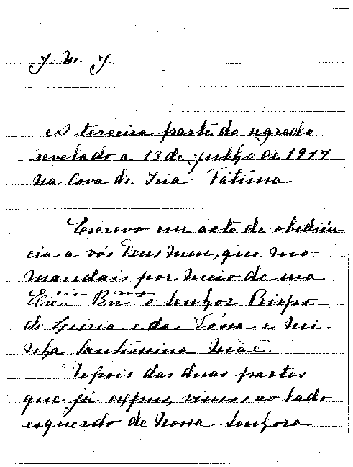
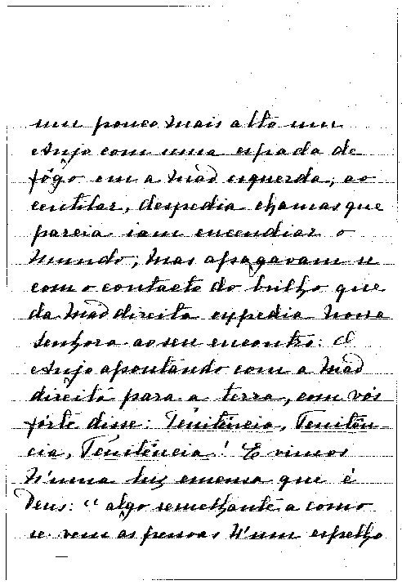
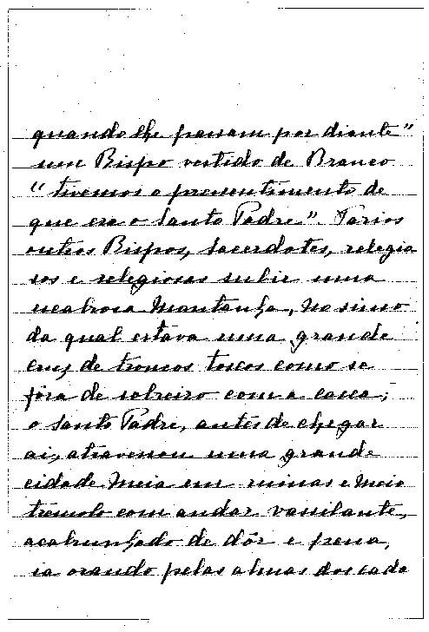
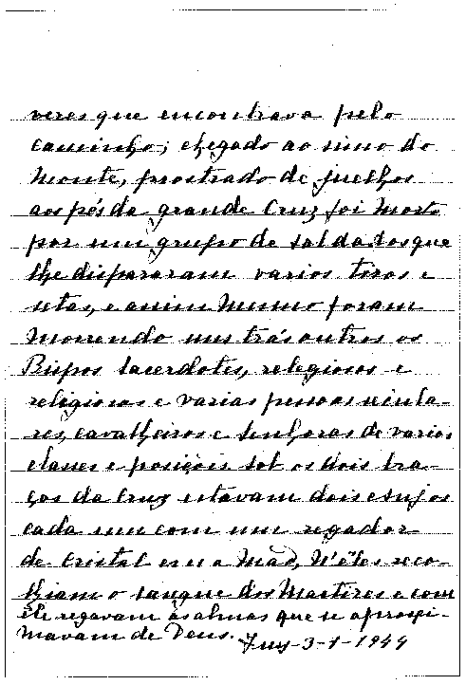

(translation) ⁽⁸⁾

“J.M.J.
The third part of the secret revealed at the Cova da Iria-Fatima, on 13 July 1917.
I write in obedience to you, my God, who command me to do so through his Excellency the Bishop of Leiria and through your Most Holy Mother and mine.
After the two parts which I have already explained, at the left of Our Lady and a little above, we saw an Angel with a flaming sword in his left hand; flashing, it gave out flames that looked as though they would set the world on fire; but they died out in contact with the splendour that Our Lady radiated towards him from her right hand: pointing to the earth with his right hand, the Angel cried out in a loud voice: ‘Penance, Penance, Penance!'. And we saw in an immense light that is God: ‘something similar to how people appear in a mirror when they pass in front of it' a Bishop dressed in White ‘we had the impression that it was the Holy Father'. Other Bishops, Priests, men and women Religious going up a steep mountain, at the top of which there was a big Cross of rough-hewn trunks as of a cork-tree with the bark; before reaching there the Holy Father passed through a big city half in ruins and half trembling with halting step, afflicted with pain and sorrow, he prayed for the souls of the corpses he met on his way; having reached the top of the mountain, on his knees at the foot of the big Cross he was killed by a group of soldiers who fired bullets and arrows at him, and in the same way there died one after another the other Bishops, Priests, men and women Religious, and various lay people of different ranks and positions. Beneath the two arms of the Cross there were two Angels each with a crystal aspersorium in his hand, in which they gathered up the blood of the Martyrs and with it sprinkled the souls that were making their way to God.
Tuy-3-1-1944”.

INTERPRETATION OF THE “SECRET”

LETTER OF HIS HOLINESS POPE JOHN PAUL II
TO SISTER LUCIA
(original text)
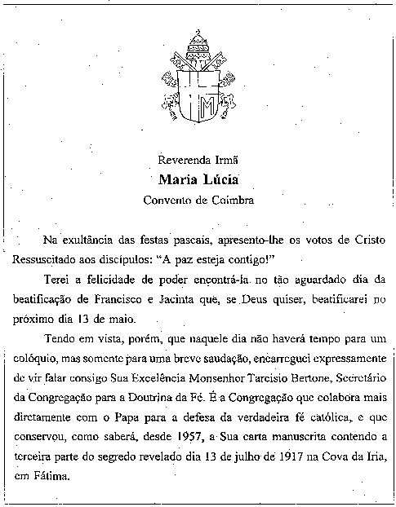
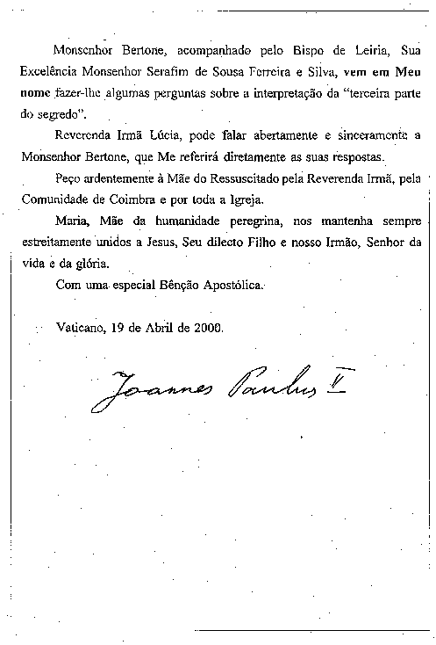

(translation)
To the Reverend Sister
Maria Lucia
of the Convent of Coimbra
In the great joy of Easter, I greet you with the words the Risen Jesus spoke to the disciples: “Peace be with you”!
I will be happy to be able to meet you on the long-awaited day of the Beatification of Francisco and Jacinta, which, please God, I will celebrate on 13 May of this year.
Since on that day there will be time only for a brief greeting and not a conversation, I am sending His Excellency Archbishop Tarcisio Bertone, Secretary of the Congregation for the Doctrine of the Faith, to speak with you. This is the Congregation which works most closely with the Pope in defending the true Catholic faith, and which since 1957, as you know, has kept your hand-written letter containing the third part of the “secret” revealed on 13 July 1917 at Cova da Iria, Fatima.
Archbishop Bertone, accompanied by the Bishop of Leiria, His Excellency Bishop Serafim de Sousa Ferreira e Silva, will come in my name to ask certain questions about the interpretation of “the third part of the secret”.
Sister Maria Lucia, you may speak openly and candidly to Archbishop Bertone, who will report your answers directly to me.
I pray fervently to the Mother of the Risen Lord for you, Reverend Sister, for the Community of Coimbra and for the whole Church. May Mary, Mother of pilgrim humanity, keep us always united to Jesus, her beloved Son and our brother, the Lord of life and glory.
With my special Apostolic Blessing.
IOANNES PAULUS PP. II
From the Vatican, 19 April 2000.
CONVERSATION
WITH SISTER MARIA LUCIA OF JESUS AND THE IMMACULATE HEART
The meeting between Sister Lucia, Archbishop Tarcisio Bertone, Secretary of the Congregation for the Doctrine of the Faith, sent by the Holy Father, and Bishop Serafim de Sousa Ferreira e Silva, Bishop of Leiria-Fatima, took place on Thursday, 27 April 2000, in the Carmel of Saint Teresa in Coimbra.
Sister Lucia was lucid and at ease; she was very happy that the Holy Father was going to Fatima for the Beatification of Francisco and Jacinta, something she had looked forward to for a long time.
The Bishop of Leiria-Fatima read the autograph letter of the Holy Father, which explained the reasons for the visit. Sister Lucia felt honoured by this and reread the letter herself, contemplating it in own her hands. She said that she was prepared to answer all questions frankly.
At this point, Archbishop Bertone presented two envelopes to her: the first containing the second, which held the third part of the “secret” of Fatima. Immediately, touching it with her fingers, she said: “This is my letter”, and then while reading it: “This is my writing”.
The original text, in Portuguese, was read and interpreted with the help of the Bishop of Leiria-Fatima. Sister Lucia agreed with the interpretation that the third part of the “secret” was a prophetic vision, similar to those in sacred history. She repeated her conviction that the vision of Fatima concerns above all the struggle of atheistic Communism against the Church and against Christians, and describes the terrible sufferings of the victims of the faith in the twentieth century.
When asked: “Is the principal figure in the vision the Pope?”, Sister Lucia replied at once that it was. She recalled that the three children were very sad about the suffering of the Pope, and that Jacinta kept saying: “Coitadinho do Santo Padre, tenho muita pena dos pecadores!” (“Poor Holy Father, I am very sad for sinners!”). Sister Lucia continued: “We did not know the name of the Pope; Our Lady did not tell us the name of the Pope; we did not know whether it was Benedict XV or Pius XII or Paul VI or John Paul II; but it was the Pope who was suffering and that made us suffer too”.
As regards the passage about the Bishop dressed in white, that is, the Holy Father—as the children immediately realized during the “vision”—who is struck dead and falls to the ground, Sister Lucia was in full agreement with the Pope's claim that “it was a mother's hand that guided the bullet's path and in his throes the Pope halted at the threshold of death” (Pope John Paul II, Meditation from the Policlinico Gemelli to the Italian Bishops, 13 May 1994).
Before giving the sealed envelope containing the third part of the “secret” to the then Bishop of Leiria-Fatima, Sister Lucia wrote on the outside envelope that it could be opened only after 1960, either by the Patriarch of Lisbon or the Bishop of Leiria. Archbishop Bertone therefore asked: “Why only after 1960? Was it Our Lady who fixed that date?” Sister Lucia replied: “It was not Our Lady. I fixed the date because I had the intuition that before 1960 it would not be understood, but that only later would it be understood. Now it can be better understood. I wrote down what I saw; however it was not for me to interpret it, but for the Pope.
Finally, mention was made of the unpublished manuscript which Sister Lucia has prepared as a reply to the many letters that come from Marian devotees and from pilgrims. The work is called Os apelos da Mensagem de Fatima, and it gathers together in the style of catechesis and exhortation thoughts and reflections which express Sister Lucia's feelings and her clear and unaffected spirituality. She was asked if she would be happy to have it published, and she replied: “If the Holy Father agrees, then I am happy, otherwise I obey whatever the Holy Father decides”. Sister Lucia wants to present the text for ecclesiastical approval, and she hopes that what she has written will help to guide men and women of good will along the path that leads to God, the final goal of every human longing.The conversation ends with an exchange of rosaries. Sister Lucia is given a rosary sent by the Holy Father, and she in turn offers a number of rosaries made by herself.
The meeting concludes with the blessing imparted in the name of the Holy Father.

ANNOUNCEMENT MADE BY CARDINAL ANGELO SODANO SECRETARY OF STATE
At the end of the Mass presided over by the Holy Father at Fatima, Cardinal Angelo Sodano, the Secretary of State, made this announcement in Portuguese, which is given here in English translation:
Brothers and Sisters in the Lord!
At the conclusion of this solemn celebration, I feel bound to offer our beloved Holy Father Pope John Paul II, on behalf of all present, heartfelt good wishes for his approaching 80th Birthday and to thank him for his vital pastoral ministry for the good of all God's Holy Church; we present the heartfelt wishes of the whole Church.
On this solemn occasion of his visit to Fatima, His Holiness has directed me to make an announcement to you. As you know, the purpose of his visit to Fatima has been to beatify the two “little shepherds”. Nevertheless he also wishes his pilgrimage to be a renewed gesture of gratitude to Our Lady for her protection during these years of his papacy. This protection seems also to be linked to the so-called third part of the “secret” of Fatima.
That text contains a prophetic vision similar to those found in Sacred Scripture, which do not describe photographically the details of future events, but synthesize and compress against a single background facts which extend through time in an unspecified succession and duration. As a result, the text must be interpreted in a symbolic key.
The vision of Fatima concerns above all the war waged by atheistic systems against the Church and Christians, and it describes the immense suffering endured by the witnesses of the faith in the last century of the second millennium. It is an interminable Way of the Cross led by the Popes of the twentieth century.
According to the interpretation of the “little shepherds”, which was also confirmed recently by Sister Lucia, “the Bishop clothed in white” who prays for all the faithful is the Pope. As he makes his way with great difficulty towards the Cross amid the corpses of those who were martyred (Bishops, priests, men and women Religious and many lay people), he too falls to the ground, apparently dead, under a hail of gunfire.
After the assassination attempt of 13 May 1981, it appeared evident that it was “a mother's hand that guided the bullet's path”, enabling “the Pope in his throes” to halt “at the threshold of death” (Pope John Paul II, Meditation from the Policlinico Gemelli to the Italian Bishops, Insegnamenti, XVII, 1 [1994], 1061). On the occasion of a visit to Rome by the then Bishop of Leiria-Fatima, the Pope decided to give him the bullet which had remained in the jeep after the assassination attempt, so that it might be kept in the shrine. By the Bishop's decision, the bullet was later set in the crown of the statue of Our Lady of Fatima.
The successive events of 1989 led, both in the Soviet Union and in a number of countries of Eastern Europe, to the fall of the Communist regimes which promoted atheism. For this too His Holiness offers heartfelt thanks to the Most Holy Virgin. In other parts of the world, however, attacks against the Church and against Christians, with the burden of suffering they bring, tragically continue. Even if the events to which the third part of the “secret” of Fatima refers now seem part of the past, Our Lady's call to conversion and penance, issued at the start of the twentieth century, remains timely and urgent today. “The Lady of the message seems to read the signs of the times—the signs of our time—with special insight... The insistent invitation of Mary Most Holy to penance is nothing but the manifestation of her maternal concern for the fate of the human family, in need of conversion and forgiveness” (Pope John Paul II, Message for the 1997 World Day of the Sick, No. 1, Insegnamenti, XIX, 2 [1996], 561).
In order that the faithful may better receive the message of Our Lady of Fatima, the Pope has charged the Congregation for the Doctrine of the Faith with making public the third part of the “secret”, after the preparation of an appropriate commentary.
Brothers and sisters, let us thank Our Lady of Fatima for her protection. To her maternal intercession let us entrust the Church of the Third Millennium.
Sub tuum praesidium confugimus, Sancta Dei Genetrix! Intercede pro Ecclesia. Intercede pro Papa nostro Ioanne Paulo II. Amen.
Fatima, 13 May 2000

THEOLOGICAL COMMENTARY
A careful reading of the text of the so-called third “secret” of Fatima, published here in its entirety long after the fact and by decision of the Holy Father, will probably prove disappointing or surprising after all the speculation it has stirred. No great mystery is revealed; nor is the future unveiled. We see the Church of the martyrs of the century which has just passed represented in a scene described in a language which is symbolic and not easy to decipher. Is this what the Mother of the Lord wished to communicate to Christianity and to humanity at a time of great difficulty and distress? Is it of any help to us at the beginning of the new millennium? Or are these only projections of the inner world of children, brought up in a climate of profound piety but shaken at the same time by the tempests which threatened their own time? How should we understand the vision? What are we to make of it?
Public Revelation and private revelations – their theological status
Before attempting an interpretation, the main lines of which can be found in the statement read by Cardinal Sodano on 13 May of this year at the end of the Mass celebrated by the Holy Father in Fatima, there is a need for some basic clarification of the way in which, according to Church teaching, phenomena such as Fatima are to be understood within the life of faith. The teaching of the Church distinguishes between “public Revelation” and “private revelations”. The two realities differ not only in degree but also in essence. The term “public Revelation” refers to the revealing action of God directed to humanity as a whole and which finds its literary expression in the two parts of the Bible: the Old and New Testaments. It is called “Revelation” because in it God gradually made himself known to men, to the point of becoming man himself, in order to draw to himself the whole world and unite it with himself through his Incarnate Son, Jesus Christ. It is not a matter therefore of intellectual communication, but of a life-giving process in which God comes to meet man. At the same time this process naturally produces data pertaining to the mind and to the understanding of the mystery of God. It is a process which involves man in his entirety and therefore reason as well, but not reason alone. Because God is one, history, which he shares with humanity, is also one. It is valid for all time, and it has reached its fulfilment in the life, death and resurrection of Jesus Christ. In Christ, God has said everything, that is, he has revealed himself completely, and therefore Revelation came to an end with the fulfilment of the mystery of Christ as enunciated in the New Testament. To explain the finality and completeness of Revelation, the Catechism of the Catholic Church quotes a text of Saint John of the Cross: “In giving us his Son, his only Word (for he possesses no other), he spoke everything to us at once in this sole Word—and he has no more to say... because what he spoke before to the prophets in parts, he has now spoken all at once by giving us the All Who is His Son. Any person questioning God or desiring some vision or revelation would be guilty not only of foolish behaviour but also of offending him, by not fixing his eyes entirely upon Christ and by living with the desire for some other novelty” (No. 65; Saint John of the Cross,The Ascent of Mount Carmel, II, 22).
Because the single Revelation of God addressed to all peoples comes to completion with Christ and the witness borne to him in the books of the New Testament, the Church is tied to this unique event of sacred history and to the word of the Bible, which guarantees and interprets it. But this does not mean that the Church can now look only to the past and that she is condemned to sterile repetition. The Catechism of the Catholic Church says in this regard: “...even if Revelation is already complete, it has not been made fully explicit; it remains for Christian faith gradually to grasp its full significance over the course of the centuries” (No. 66). The way in which the Church is bound to both the uniqueness of the event and progress in understanding it is very well illustrated in the farewell discourse of the Lord when, taking leave of his disciples, he says: “I have yet many things to say to you, but you cannot bear them now. When the Spirit of truth comes, he will guide you into all the truth; for he will not speak on his own authority... He will glorify me, for he will take what is mine and declare it to you” (Jn 16:12-14). On the one hand, the Spirit acts as a guide who discloses a knowledge previously unreachable because the premise was missing—this is the boundless breadth and depth of Christian faith. On the other hand, to be guided by the Spirit is also “to draw from” the riches of Jesus Christ himself, the inexhaustible depths of which appear in the way the Spirit leads. In this regard, the Catechism cites profound words of Pope Gregory the Great: “The sacred Scriptures grow with the one who reads them” (No. 94; Gregory the Great,Homilia in Ezechielem I, 7, 8). The Second Vatican Council notes three essential ways in which the Spirit guides in the Church, and therefore three ways in which “the word grows”: through the meditation and study of the faithful, through the deep understanding which comes from spiritual experience, and through the preaching of “those who, in the succession of the episcopate, have received the sure charism of truth” (Dei Verbum, 8).
In this context, it now becomes possible to understand rightly the concept of “private revelation”, which refers to all the visions and revelations which have taken place since the completion of the New Testament. This is the category to which we must assign the message of Fatima. In this respect, let us listen once again to the Catechism of the Catholic Church: “Throughout the ages, there have been so-called ‘private' revelations, some of which have been recognized by the authority of the Church... It is not their role to complete Christ's definitive Revelation, but to help live more fully by it in a certain period of history” (No. 67). This clarifies two things:
1. The authority of private revelations is essentially different from that of the definitive public Revelation. The latter demands faith; in it in fact God himself speaks to us through human words and the mediation of the living community of the Church. Faith in God and in his word is different from any other human faith, trust or opinion. The certainty that it is God who is speaking gives me the assurance that I am in touch with truth itself. It gives me a certitude which is beyond verification by any human way of knowing. It is the certitude upon which I build my life and to which I entrust myself in dying.
2. Private revelation is a help to this faith, and shows its credibility precisely by leading me back to the definitive public Revelation. In this regard, Cardinal Prospero Lambertini, the future Pope Benedict XIV, says in his classic treatise, which later became normative for beatifications and canonizations: “An assent of Catholic faith is not due to revelations approved in this way; it is not even possible. These revelations seek rather an assent of human faith in keeping with the requirements of prudence, which puts them before us as probable and credible to piety”. The Flemish theologian E. Dhanis, an eminent scholar in this field, states succinctly that ecclesiastical approval of a private revelation has three elements: the message contains nothing contrary to faith or morals; it is lawful to make it public; and the faithful are authorized to accept it with prudence (E. Dhanis,Sguardo su Fatima e bilancio di una discussione, in La Civiltà Cattolica 104 [1953], II, 392-406, in particular 397). Such a message can be a genuine help in understanding the Gospel and living it better at a particular moment in time; therefore it should not be disregarded. It is a help which is offered, but which one is not obliged to use.
The criterion for the truth and value of a private revelation is therefore its orientation to Christ himself. When it leads us away from him, when it becomes independent of him or even presents itself as another and better plan of salvation, more important than the Gospel, then it certainly does not come from the Holy Spirit, who guides us more deeply into the Gospel and not away from it. This does not mean that a private revelation will not offer new emphases or give rise to new devotional forms, or deepen and spread older forms. But in all of this there must be a nurturing of faith, hope and love, which are the unchanging path to salvation for everyone. We might add that private revelations often spring from popular piety and leave their stamp on it, giving it a new impulse and opening the way for new forms of it. Nor does this exclude that they will have an effect even on the liturgy, as we see for instance in the feasts of Corpus Christi and of the Sacred Heart of Jesus. From one point of view, the relationship between Revelation and private revelations appears in the relationship between the liturgy and popular piety: the liturgy is the criterion, it is the living form of the Church as a whole, fed directly by the Gospel. Popular piety is a sign that the faith is spreading its roots into the heart of a people in such a way that it reaches into daily life. Popular religiosity is the first and fundamental mode of “inculturation” of the faith. While it must always take its lead and direction from the liturgy, it in turn enriches the faith by involving the heart.
We have thus moved from the somewhat negative clarifications, initially needed, to a positive definition of private revelations. How can they be classified correctly in relation to Scripture? To which theological category do they belong? The oldest letter of Saint Paul which has been preserved, perhaps the oldest of the New Testament texts, the First Letter to the Thessalonians, seems to me to point the way. The Apostle says: “Do not quench the Spirit, do not despise prophesying, but test everything, holding fast to what is good” (5:19-21). In every age the Church has received the charism of prophecy, which must be scrutinized but not scorned. On this point, it should be kept in mind that prophecy in the biblical sense does not mean to predict the future but to explain the will of God for the present, and therefore show the right path to take for the future. A person who foretells what is going to happen responds to the curiosity of the mind, which wants to draw back the veil on the future. The prophet speaks to the blindness of will and of reason, and declares the will of God as an indication and demand for the present time. In this case, prediction of the future is of secondary importance. What is essential is the actualization of the definitive Revelation, which concerns me at the deepest level. The prophetic word is a warning or a consolation, or both together. In this sense there is a link between the charism of prophecy and the category of “the signs of the times”, which Vatican II brought to light anew: “You know how to interpret the appearance of earth and sky; why then do you not know how to interpret the present time?” (Lk 12:56). In this saying of Jesus, the “signs of the times” must be understood as the path he was taking, indeed it must be understood as Jesus himself. To interpret the signs of the times in the light of faith means to recognize the presence of Christ in every age. In the private revelations approved by the Church—and therefore also in Fatima—this is the point: they help us to understand the signs of the times and to respond to them rightly in faith.
The anthropological structure of private revelations
In these reflections we have sought so far to identify the theological status of private revelations. Before undertaking an interpretation of the message of Fatima, we must still attempt briefly to offer some clarification of their anthropological (psychological) character. In this field, theological anthropology distinguishes three forms of perception or “vision”: vision with the senses, and hence exterior bodily perception, interior perception, and spiritual vision (visio sensibilis - imaginativa - intellectualis). It is clear that in the visions of Lourdes, Fatima and other places it is not a question of normal exterior perception of the senses: the images and forms which are seen are not located spatially, as is the case for example with a tree or a house. This is perfectly obvious, for instance, as regards the vision of hell (described in the first part of the Fatima “secret”) or even the vision described in the third part of the “secret”. But the same can be very easily shown with regard to other visions, especially since not everybody present saw them, but only the “visionaries”. It is also clear that it is not a matter of a “vision” in the mind, without images, as occurs at the higher levels of mysticism. Therefore we are dealing with the middle category, interior perception. For the visionary, this perception certainly has the force of a presence, equivalent for that person to an external manifestation to the senses.
Interior vision does not mean fantasy, which would be no more than an expression of the subjective imagination. It means rather that the soul is touched by something real, even if beyond the senses. It is rendered capable of seeing that which is beyond the senses, that which cannot be seen—seeing by means of the “interior senses”. It involves true “objects”, which touch the soul, even if these “objects” do not belong to our habitual sensory world. This is why there is a need for an interior vigilance of the heart, which is usually precluded by the intense pressure of external reality and of the images and thoughts which fill the soul. The person is led beyond pure exteriority and is touched by deeper dimensions of reality, which become visible to him. Perhaps this explains why children tend to be the ones to receive these apparitions: their souls are as yet little disturbed, their interior powers of perception are still not impaired. “On the lips of children and of babes you have found praise”, replies Jesus with a phrase of Psalm 8 (v. 3) to the criticism of the High Priests and elders, who had judged the children's cries of “hosanna” inappropriate (cf. Mt 21:16).
“Interior vision” is not fantasy but, as we have said, a true and valid means of verification. But it also has its limitations. Even in exterior vision the subjective element is always present. We do not see the pure object, but it comes to us through the filter of our senses, which carry out a work of translation. This is still more evident in the case of interior vision, especially when it involves realities which in themselves transcend our horizon. The subject, the visionary, is still more powerfully involved. He sees insofar as he is able, in the modes of representation and consciousness available to him. In the case of interior vision, the process of translation is even more extensive than in exterior vision, for the subject shares in an essential way in the formation of the image of what appears. He can arrive at the image only within the bounds of his capacities and possibilities. Such visions therefore are never simple “photographs” of the other world, but are influenced by the potentialities and limitations of the perceiving subject.
This can be demonstrated in all the great visions of the saints; and naturally it is also true of the visions of the children at Fatima. The images described by them are by no means a simple expression of their fantasy, but the result of a real perception of a higher and interior origin. But neither should they be thought of as if for a moment the veil of the other world were drawn back, with heaven appearing in its pure essence, as one day we hope to see it in our definitive union with God. Rather the images are, in a manner of speaking, a synthesis of the impulse coming from on high and the capacity to receive this impulse in the visionaries, that is, the children. For this reason, the figurative language of the visions is symbolic. In this regard, Cardinal Sodano stated: “[they] do not describe photographically the details of future events, but synthesize and compress against a single background facts which extend through time in an unspecified succession and duration”. This compression of time and place in a single image is typical of such visions, which for the most part can be deciphered only in retrospect. Not every element of the vision has to have a specific historical sense. It is the vision as a whole that matters, and the details must be understood on the basis of the images taken in their entirety. The central element of the image is revealed where it coincides with what is the focal point of Christian “prophecy” itself: the centre is found where the vision becomes a summons and a guide to the will of God.
An attempt to interpret the “secret” of Fatima
The first and second parts of the “secret” of Fatima have already been so amply discussed in the relative literature that there is no need to deal with them again here. I would just like to recall briefly the most significant point. For one terrible moment, the children were given a vision of hell. They saw the fall of “the souls of poor sinners”. And now they are told why they have been exposed to this moment: “in order to save souls”—to show the way to salvation. The words of the First Letter of Peter come to mind: “As the outcome of your faith you obtain the salvation of your souls” (1:9). To reach this goal, the way indicated —surprisingly for people from the Anglo-Saxon and German cultural world—is devotion to the Immaculate Heart of Mary. A brief comment may suffice to explain this. In biblical language, the “heart” indicates the centre of human life, the point where reason, will, temperament and sensitivity converge, where the person finds his unity and his interior orientation. According to Matthew 5:8, the “immaculate heart” is a heart which, with God's grace, has come to perfect interior unity and therefore “sees God”. To be “devoted” to the Immaculate Heart of Mary means therefore to embrace this attitude of heart, which makes the fiat—“your will be done”—the defining centre of one's whole life. It might be objected that we should not place a human being between ourselves and Christ. But then we remember that Paul did not hesitate to say to his communities: “imitate me” (1 Cor 4:16; Phil 3:17; 1 Th 1:6; 2 Th 3:7, 9). In the Apostle they could see concretely what it meant to follow Christ. But from whom might we better learn in every age than from the Mother of the Lord?
Thus we come finally to the third part of the “secret” of Fatima which for the first time is being published in its entirety. As is clear from the documentation presented here, the interpretation offered by Cardinal Sodano in his statement of 13 May was first put personally to Sister Lucia. Sister Lucia responded by pointing out that she had received the vision but not its interpretation. The interpretation, she said, belonged not to the visionary but to the Church. After reading the text, however, she said that this interpretation corresponded to what she had experienced and that on her part she thought the interpretation correct. In what follows, therefore, we can only attempt to provide a deeper foundation for this interpretation, on the basis of the criteria already considered.
“To save souls” has emerged as the key word of the first and second parts of the “secret”, and the key word of this third part is the threefold cry: “Penance, Penance, Penance!” The beginning of the Gospel comes to mind: “Repent and believe the Good News” (Mk 1:15). To understand the signs of the times means to accept the urgency of penance – of conversion – of faith. This is the correct response to this moment of history, characterized by the grave perils outlined in the images that follow. Allow me to add here a personal recollection: in a conversation with me Sister Lucia said that it appeared ever more clearly to her that the purpose of all the apparitions was to help people to grow more and more in faith, hope and love—everything else was intended to lead to this.
Let us now examine more closely the single images. The angel with the flaming sword on the left of the Mother of God recalls similar images in the Book of Revelation. This represents the threat of judgement which looms over the world. Today the prospect that the world might be reduced to ashes by a sea of fire no longer seems pure fantasy: man himself, with his inventions, has forged the flaming sword. The vision then shows the power which stands opposed to the force of destruction—the splendour of the Mother of God and, stemming from this in a certain way, the summons to penance. In this way, the importance of human freedom is underlined: the future is not in fact unchangeably set, and the image which the children saw is in no way a film preview of a future in which nothing can be changed. Indeed, the whole point of the vision is to bring freedom onto the scene and to steer freedom in a positive direction. The purpose of the vision is not to show a film of an irrevocably fixed future. Its meaning is exactly the opposite: it is meant to mobilize the forces of change in the right direction. Therefore we must totally discount fatalistic explanations of the “secret”, such as, for example, the claim that the would-be assassin of 13 May 1981 was merely an instrument of the divine plan guided by Providence and could not therefore have acted freely, or other similar ideas in circulation. Rather, the vision speaks of dangers and how we might be saved from them.
The next phrases of the text show very clearly once again the symbolic character of the vision: God remains immeasurable, and is the light which surpasses every vision of ours. Human persons appear as in a mirror. We must always keep in mind the limits in the vision itself, which here are indicated visually. The future appears only “in a mirror dimly” (1 Cor 13:12). Let us now consider the individual images which follow in the text of the “secret”. The place of the action is described in three symbols: a steep mountain, a great city reduced to ruins and finally a large rough-hewn cross. The mountain and city symbolize the arena of human history: history as an arduous ascent to the summit, history as the arena of human creativity and social harmony, but at the same time a place of destruction, where man actually destroys the fruits of his own work. The city can be the place of communion and progress, but also of danger and the most extreme menace. On the mountain stands the cross—the goal and guide of history. The cross transforms destruction into salvation; it stands as a sign of history's misery but also as a promise for history.
At this point human persons appear: the Bishop dressed in white (“we had the impression that it was the Holy Father”), other Bishops, priests, men and women Religious, and men and women of different ranks and social positions. The Pope seems to precede the others, trembling and suffering because of all the horrors around him. Not only do the houses of the city lie half in ruins, but he makes his way among the corpses of the dead. The Church's path is thus described as a Via Crucis, as a journey through a time of violence, destruction and persecution. The history of an entire century can be seen represented in this image. Just as the places of the earth are synthetically described in the two images of the mountain and the city, and are directed towards the cross, so too time is presented in a compressed way. In the vision we can recognize the last century as a century of martyrs, a century of suffering and persecution for the Church, a century of World Wars and the many local wars which filled the last fifty years and have inflicted unprecedented forms of cruelty. In the “mirror” of this vision we see passing before us the witnesses of the faith decade by decade. Here it would be appropriate to mention a phrase from the letter which Sister Lucia wrote to the Holy Father on 12 May 1982: “The third part of the ‘secret' refers to Our Lady's words: ‘If not, [Russia] will spread her errors throughout the world, causing wars and persecutions of the Church. The good will be martyred; the Holy Father will have much to suffer; various nations will be annihilated'”.
In the Via Crucis of an entire century, the figure of the Pope has a special role. In his arduous ascent of the mountain we can undoubtedly see a convergence of different Popes. Beginning from Pius X up to the present Pope, they all shared the sufferings of the century and strove to go forward through all the anguish along the path which leads to the Cross. In the vision, the Pope too is killed along with the martyrs. When, after the attempted assassination on 13 May 1981, the Holy Father had the text of the third part of the “secret” brought to him, was it not inevitable that he should see in it his own fate? He had been very close to death, and he himself explained his survival in the following words: “... it was a mother's hand that guided the bullet's path and in his throes the Pope halted at the threshold of death” (13 May 1994). That here “a mother's hand” had deflected the fateful bullet only shows once more that there is no immutable destiny, that faith and prayer are forces which can influence history and that in the end prayer is more powerful than bullets and faith more powerful than armies.
The concluding part of the “secret” uses images which Lucia may have seen in devotional books and which draw their inspiration from long-standing intuitions of faith. It is a consoling vision, which seeks to open a history of blood and tears to the healing power of God. Beneath the arms of the cross angels gather up the blood of the martyrs, and with it they give life to the souls making their way to God. Here, the blood of Christ and the blood of the martyrs are considered as one: the blood of the martyrs runs down from the arms of the cross. The martyrs die in communion with the Passion of Christ, and their death becomes one with his. For the sake of the body of Christ, they complete what is still lacking in his afflictions (cf. Col 1:24). Their life has itself become a Eucharist, part of the mystery of the grain of wheat which in dying yields abundant fruit. The blood of the martyrs is the seed of Christians, said Tertullian. As from Christ's death, from his wounded side, the Church was born, so the death of the witnesses is fruitful for the future life of the Church. Therefore, the vision of the third part of the “secret”, so distressing at first, concludes with an image of hope: no suffering is in vain, and it is a suffering Church, a Church of martyrs, which becomes a sign-post for man in his search for God. The loving arms of God welcome not only those who suffer like Lazarus, who found great solace there and mysteriously represents Christ, who wished to become for us the poor Lazarus. There is something more: from the suffering of the witnesses there comes a purifying and renewing power, because their suffering is the actualization of the suffering of Christ himself and a communication in the here and now of its saving effect.
And so we come to the final question: What is the meaning of the “secret” of Fatima as a whole (in its three parts)? What does it say to us? First of all we must affirm with Cardinal Sodano: “... the events to which the third part of the ‘secret' of Fatima refers now seem part of the past”. Insofar as individual events are described, they belong to the past. Those who expected exciting apocalyptic revelations about the end of the world or the future course of history are bound to be disappointed. Fatima does not satisfy our curiosity in this way, just as Christian faith in general cannot be reduced to an object of mere curiosity. What remains was already evident when we began our reflections on the text of the “secret”: the exhortation to prayer as the path of “salvation for souls” and, likewise, the summons to penance and conversion.
I would like finally to mention another key expression of the “secret” which has become justly famous: “my Immaculate Heart will triumph”. What does this mean? The Heart open to God, purified by contemplation of God, is stronger than guns and weapons of every kind. The fiat of Mary, the word of her heart, has changed the history of the world, because it brought the Saviour into the world—because, thanks to her Yes, God could become man in our world and remains so for all time. The Evil One has power in this world, as we see and experience continually; he has power because our freedom continually lets itself be led away from God. But since God himself took a human heart and has thus steered human freedom towards what is good, the freedom to choose evil no longer has the last word. From that time forth, the word that prevails is this: “In the world you will have tribulation, but take heart; I have overcome the world” (Jn 16:33). The message of Fatima invites us to trust in this promise.

JosephCard. Ratzinger
Prefect of the Congregation for the Doctrine of the Faith

(1) From the diary of John XXIII, 17 August 1959: “Audiences: Father Philippe, Commissary of the Holy Office, who brought me the letter containing the third part of the secrets of Fatima. I intend to read it with my Confessor”.
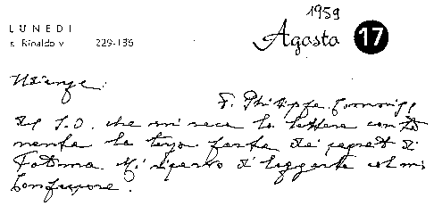
(2) The Holy Father's comment at the General Audience of 14 October 1981 on “What happened in May: A Great Divine Trial” should be recalled: Insegnamenti di Giovanni Paolo II, IV, 2 (Vatican City, 1981), 409-412.
(3) Radio message during the Ceremony of Veneration, Thanksgiving and Entrustment to the Virgin Mary Theotokos in the Basilica of Saint Mary Major: Insegnamenti di Giovanni Paolo II, IV, 1 (Vatican City, 1981), 1246.
(4) On the Jubilee Day for Families, the Pope entrusted individuals and nations to Our Lady: Insegnamenti di Giovanni Paolo II, VII, 1 (Vatican City, 1984), 775-777.
(5)
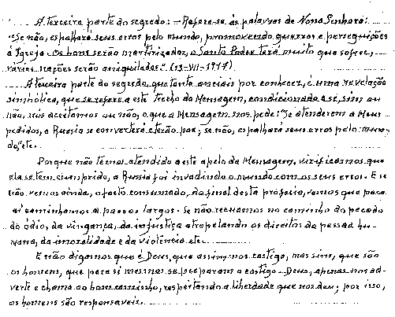
(6) In the “Fourth Memoir” of 8 December 1941 Sister Lucia writes: “I shall begin then my new task, and thus fulfil the commands received from Your Excellency as well as the desires of Dr Galamba. With the exception of that part of the Secret which I am not permitted to reveal at present, I shall say everything. I shall not knowingly omit anything, though I suppose I may forget just a few small details of minor importance”.
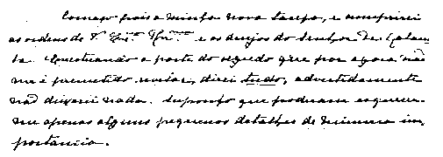
(7) In the “Fourth Memoir” Sister Lucia adds: “In Portugal, the dogma of the faith will always be preserved, etc. ...”.
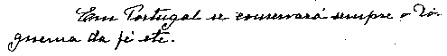
(8) In the translation, the original text has been respected, even as regards the imprecise punctuation, which nevertheless does not impede an understanding of what the visionary wished to say.

